School of Modern Greek Language
Prospective students’ portal – User guide

Prospective students can submit their applications by registering online, through the school’s portal. The process of applying as a prospective student consists of the following steps:
- Create an account
- Login, create an application
- Fill in the application form
- Upload the required documents
- Submit the application

Create an account
Go to the portal’s web site and click “Sign up”
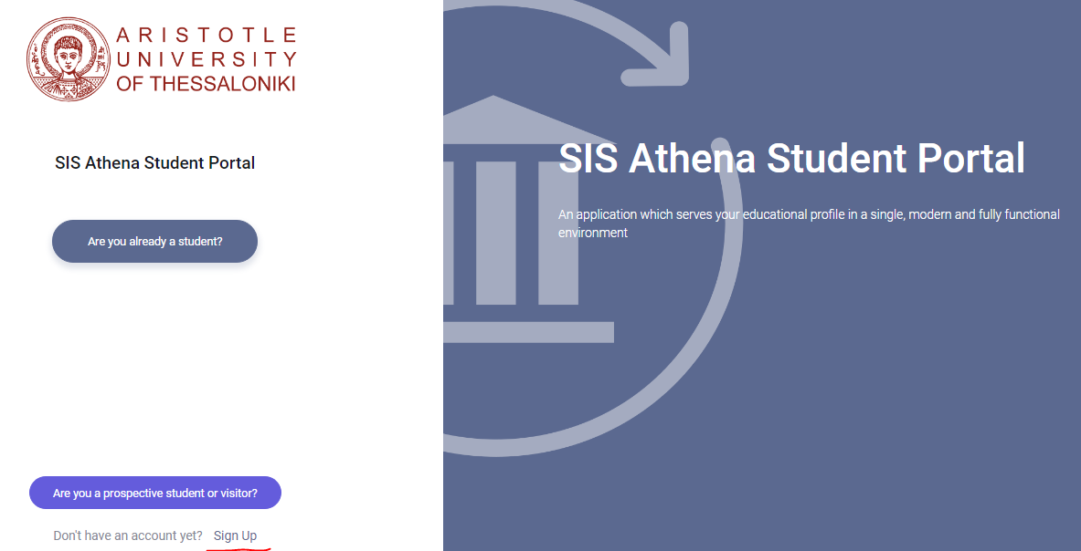
Type in all the required information and press “Next”. Then, fill in your contact details and press “Submit”. At that point the system notifies you that a message is sent to your email address, regarding activation of your account. For that to happen, you need to make sure that you enter a valid email address that you have access to and is not already being used for another account on the portal. Your email address is going to be your unique ID, so make sure you treat it as such.
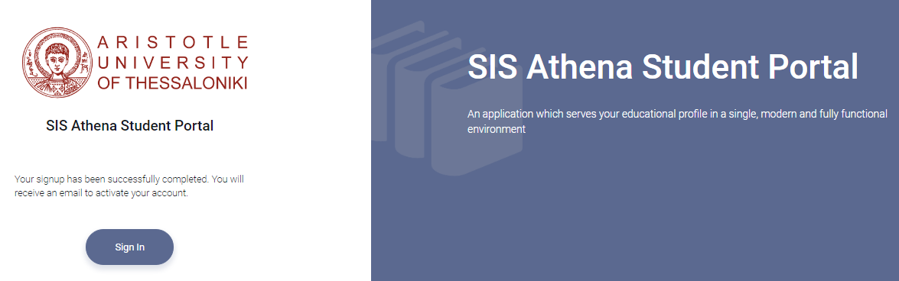
The next thig to do is check your email. You should have received a message similar to the following. Press “Activate my account”. As stated in the message, you must click the activation button and resume the activation process within a certain time, beyond which your account cannot be activated. If the activation times out, simply start all over again by signing up.

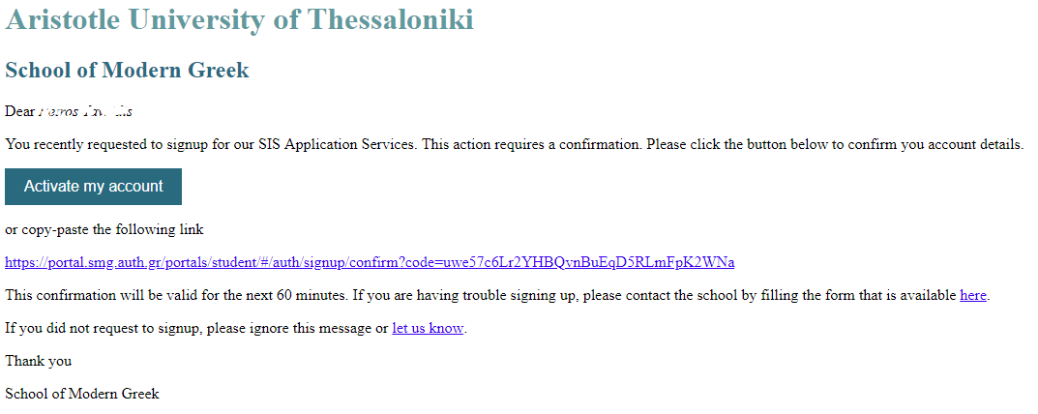
Once the activation button is clicked, you are transferred to the Sign Up Confirmation page. Here you get to type in your desired password. Note that this is NOT a login page – you are still in the process of activating your account.
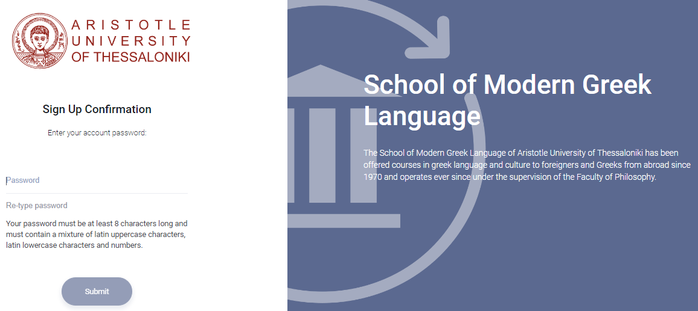
Your password must meet certain requirements as stated on the page. Once your password is typed (and re-typed), press Submit. Note that the Submit button becomes enabled only if you stick to the password rules. Once your password is submitted successfully, you can login to the portal. The process takes you to the login screen.

Login, create an application
Here you get type in the email address you entered at the beginning of the process and the password that you specified.
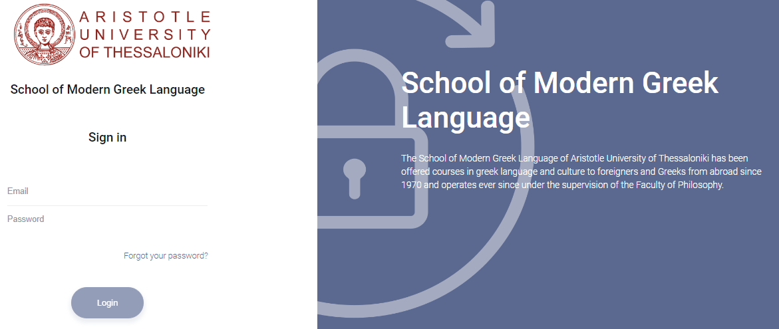
Once logged in, press New Request on the top right. A blank application form loads, where you have to fill in the required data. ALL fields must be filled in.
If, for any reason, you sign out and re-visit your application later on, all you have to do is press the “Are you a prospective student or visitor?” button and sign in again with your email and password.

Fill in the application form
As state above, ALL field must be filled in. However, take extra care to specify the right class, as this will determine that dates, shift and group that you will attend once your application is accepted.
Use the Save button at the bottom of the application form to save your data so can visit your application at any time and modify it.

Upload the required documents
Once your application is saved, the Attachments tab becomes enabled and you can upload the required documents.
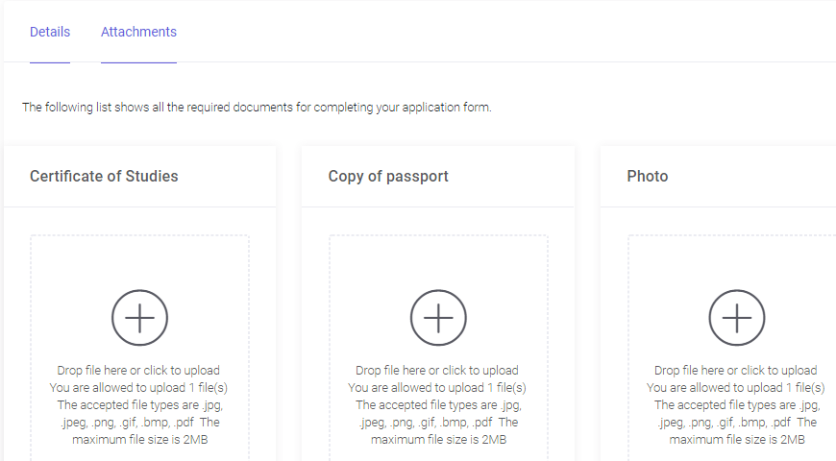
Three types of documents are required for your application to be valid, as shown above. You can only upload one file per document type, so if your document consists of more than one page, make sure it is bundled in one file, not separate files per page.

Submit the application
Once your application is completed you can press the Submit button. The school’s registrar will evaluate your application and – assuming everything is in place – you will soon afterwards be notified that your application has been accepted.

